ACCESS TO SHEREPOINT VIA AZURE
Granting access to sharepoint Via Azure with available some available data but with some limitations to Read, or Write.

Having this info’s with the permission to only select files

SECURITY GROUP : CCTSecurityGroup
Fist You must be an Admin on the site you want to access, or an admin must add this security group to the site with the permission to read or write.
Do as follow :
- Access Site Permissions

- Advanced Permissions Settings

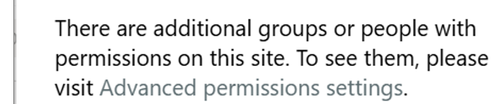

- Grand Permission
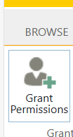

- Finally Add this CCTSecurityGroup to the security group.

## The Solution: The Admin Must Find the Site ID Manually
The administrator needs to use their own permissions to find the Site ID first. Once they have the ID, they can grant your app access to it.
Please provide the following step-by-step instructions to your SharePoint Administrator.

## Instructions for the Administrator
Step 1: Sign in to Graph Explorer
Go to the Microsoft Graph Explorer and sign in with your Administrator account.

Step 2: Find the Site ID
You will now run a command to get the details of the site, including its unique ID.
- Make sure the request type is set to GET.
- In the URL field, enter the following query:
- https://graph.microsoft.com/v1.0/sites/dpdhl.sharepoint.com:/teams/LLPValueCreation
- Click Run query.
Because you are an administrator, this request will succeed. The response will be a JSON object containing the site's information. Copy the id value from the response.
It will look like this:
JSON

{
"@odata.context": "https://graph.microsoft.com/v1.0/$metadata#sites/$entity",
"id": "dpdhl.sharepoint.com,a1b2c3d4-e5f6-a7b8-c9d0-e1f2a3b4c5d6,e1f2a3b4-c5d6-e7f8-a9b0-c1d2e3f4a5b6", // <-- COPY THIS ID
"displayName": "LLP Value Creation",
"name": "LLPValueCreation",
"createdDateTime": "2024-01-10T15:30:00Z",
"lastModifiedDateTime": "2025-09-18T11:00:00Z",
"webUrl": "https://dpdhl.sharepoint.com/teams/LLPValueCreation"
}

Step 3: Grant Permission to the App
Now that you have the correct Site ID, you can grant the app access.
- Change the request type to POST.
- In the URL field, enter the following, replacing {site-id} with the ID you just copied:
- https://graph.microsoft.com/v1.0/sites/{site-id}/permissions
- In the Request body, paste the following JSON, making sure to use the correct Application (client) ID for the app.
JSON
{
"roles": ["read"],
"grantedToIdentities": [{
"application": {
"id": "YOUR-APP-ID-GOES-HERE",
"displayName": "Your-App-Name-Goes-Here"
}
}]
}

"id": "YOUR-APP-ID-GOES-HERE", --- this app id now is the client id of your azure account.

